Water from the Roof

A Rainwater Harvesting Guide

Rainwater harvesting is an ancient water supply approach that can be overlooked.
Rain is a free source of high-quality water that can be used in many ways around the house for both outdoor and indoor uses. For households that have limited water supply, rainwater harvesting can reduce the burden of hauling water.
There are currently 2,177 colonias across the U.S.-Mexico border that lack water and or sewer services, creating a major need for resources in these communities.
Due to this concern, The United States Department of Agriculture, EPA Region 6 Funding through the North American Development Board (NADB) Project #1015, Border 2020, UTEP, and CERM; authorize a grant to create a rainwater harvesting guide to help the communities collect rainwater at their homes.

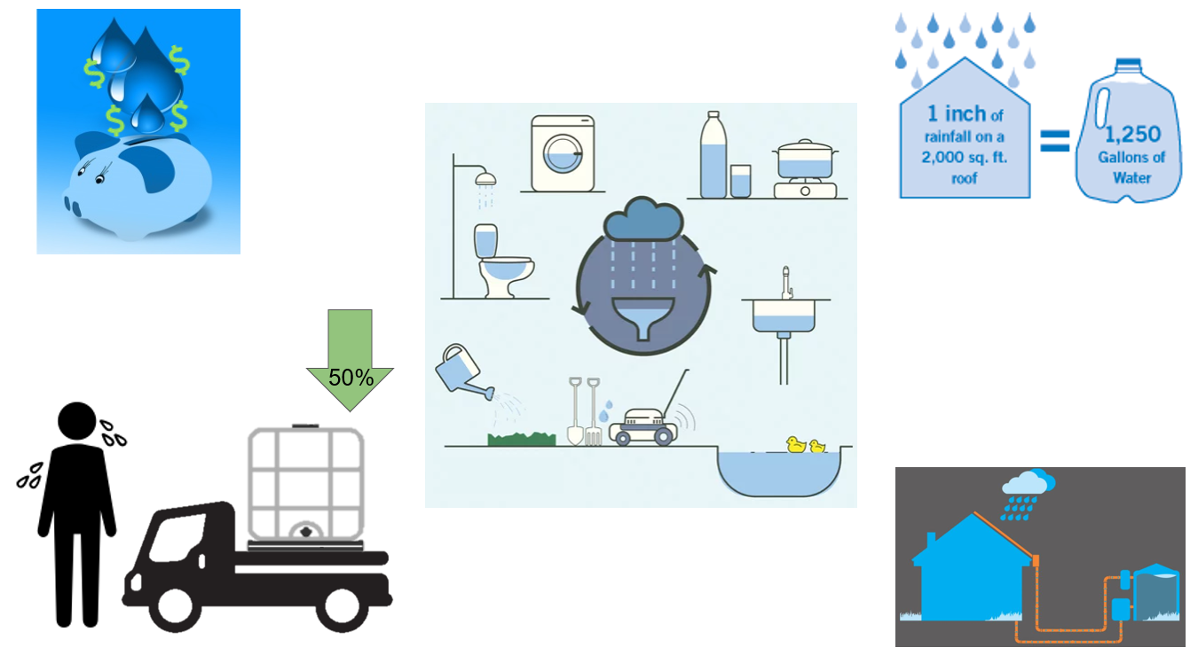
A Rainwater Harvesting System
Reduce Hauling
Did You Know?
Ways to Use Rainwater
Save Water and $

Objective: The objective of this guide is to explain how to design, install, and maintain a rainwater system at your house and collect large amounts of rainwater. For instance, just one-tenth of an inch of rain, a tiny storm, on 1,000 square feet, the roof of a small house, can produce 62 gallons (1,000 (ft^2) x .623 x 0.1” = 62.3 gallons.
Guide to Rainwater Harvesting:
Planning: Estimate the collection capacity around the home. The collection capacity is determined by the annual rainfall and the area of the roof. It is recommended to have enough storage capacity to be able to collect about half of the annual rainfall from the roof.
To measure the size of the roof, divide the roof into the parts that slope in the same direction. The area of each part is the width times the length. Add up all the parts to get the total area. To get the total collection capacity find the number of inches of rain per year online and multiply that by the area.
The next step is to determine what size and how many tanks should be used. This can depend on the price or if you can acquire donated tanks. Make sure that the tanks are near the water source and where you want to use the water. A rooftop rainwater harvesting system generally has six components. The roof, gutters to catch the water, pipe to move the collected water into the tank, filters and storage.
Tools: Tools needed to install rainwater harvesting systems include drills, shovels, tampers, ladders, saws, measuring tape, levels, safety goggles, heavy-duty scissors, wheel barrels, and picks.
Measuring a Home

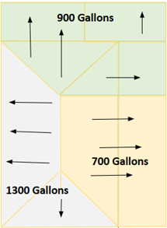

Roof Slope

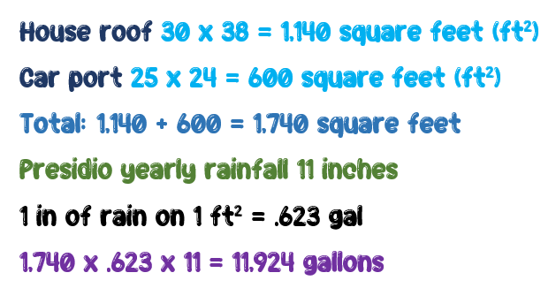
Calculation Example

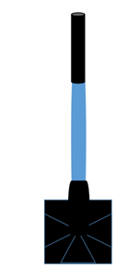
Level
Pick

Tamper

Tank Preparation Steps

First: Make sure that the tanks are food grade (only safe products used to make food or drinks had been stored in them before) Do not use tanks that have had industrial chemicals, pesticides, or other harmful chemicals that could affect your health.
Second: The tanks need to be thoroughly washed with a detergent cleaning solution, rinsed with clean water and then bleach, and finally rinsed with clean water.
Third: After cleaning, if not already black, the tanks should be painted black (black ultraviolet resistant paint is preferred) to help preserve them against the rays of the sun and so that bacteria doesn’t grow inside. Using water-based paint is recommended. The suggested primer is one in latex form. Avoid using oil-based paints, as these will not stick to the plastic tanks. Plastic tanks are available in capacities from 50 gallons to 10,000 gallons.
Foundation: The tanks need a solid foundation to sit on. This can be directly on the ground, or on a simple structure like concrete blocks or small wooden pallets. Tools like a shovel, garden hoe, pick, and tamper tool will be needed level the ground.
Next add materials like cinder blocks to raise the tanks so that water can gravity feed into the system. (Make sure that the cinder blocks are all aligned and level). Without these, a pump will be needed to help release the water. Gravity will only help the system if the tanks are higher than the desired area of use. If the tanks are not raised, pea gravel is a good foundation. Water weighs about eight pounds per gallon, which could cause leaning and tanks to collapse. Therefore, tanks should be placed on a stable, level area.
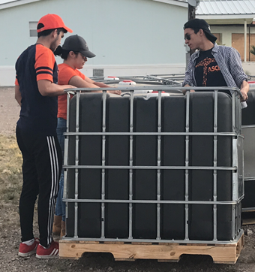

A Painted Tank

Leveling the Area

Adding Cinder Blocks

Collection: Plastic gutters are the cheapest and easiest material to install to collect the water runoff from the roof.
When installing gutters, look at how the water is coming off the roof and how to make the water flow better into the tanks. A drill and ladder are needed to install the gutters on the roof. Gutters should be placed below the roof edge and any flashing attached to the eve of the house to ensure the water runoff goes into the gutter. Gutter hangers should be placed about every three feet.
For improved water flow, apply a slope to gutters in the direction of the tank, generally dropping about one inch every 20 feet of gutter. Not having a slope can cause backflow and collect insects and debris. A chalk line can be used to place the gutters at uniform slope.
It is essential to inspect and clean the gutters before the rainy season. Water overflowing from gutters can be caused by over-hanging trees or litter that has filled up the gutters. In addition to the gutter hangers, you will need a gutter end cap for the high end of the gutter, and a gutter drop outlet for the low end of the gutter.
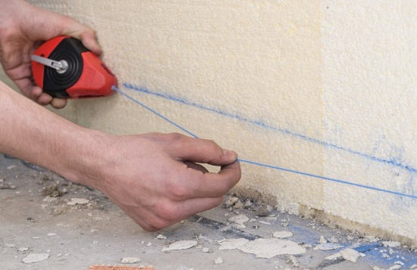

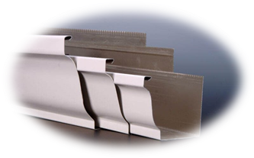
Gutter of Many Sizes

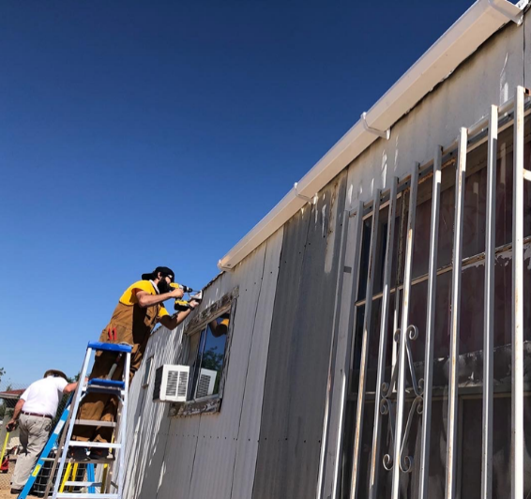

Installing Gutters

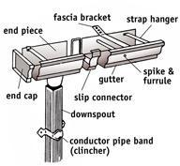
Chalk Line
Gutter Items

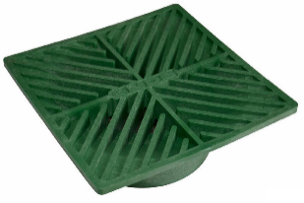
Downspout and Overflow: First move the tanks in place and make sure that the containers are placed with the opening to the side where the water will come out. Next connect the gutters to the tanks with plastic (PVC) pipes. Adding filters is part of the pipe connection process.
Different types of filters can be used. The main three are:
a) In-line with the gutters.
b) Leaf screens: this filter is placed on top of the downspout. (Leaf screens filters help remove larger pieces of litter).
c) First flush diverters are connected to a downspout. (first flush can get rid of smaller things like dust and animal droppings). The first flush should let go of at least 10 gallons for every 1,000 square feet of roof area. The first flush pipe is attached to a wall or post. This pipe needs to be emptied after every rain.
The first flush system includes a cleanout fitting plug, fitting elbow, and cleanout adapter.

It is important to keep the design simple so that the maintenance can also be easier and require less money and time.
The downspout carries the water from the gutters to the tank. Size the downspout and pipe according to the anticipated volume of water. You can ask your local hardware store for help on this. The downspout also needs a slope so that water does not get stuck and allow bacteria to grow. An overflow component can be added to the downspout or to the tank. The overflow is used for when it rains a lot and the tanks get too full.
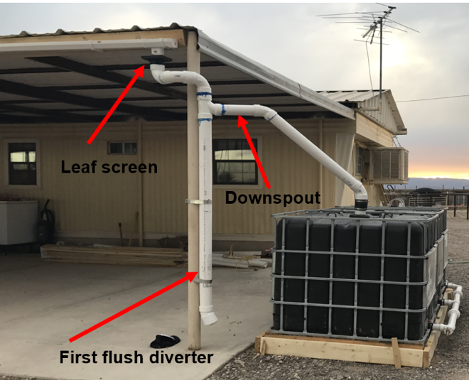
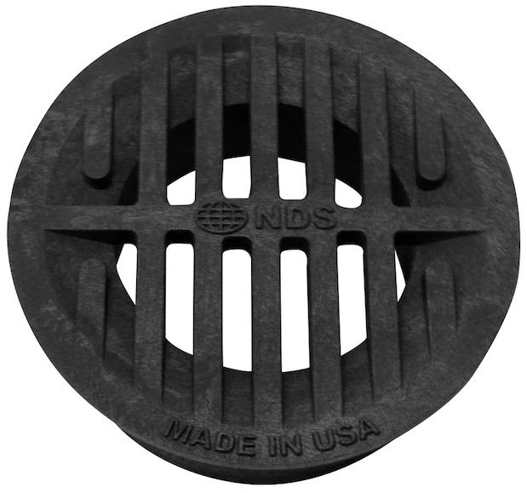
Filters
Example System 1
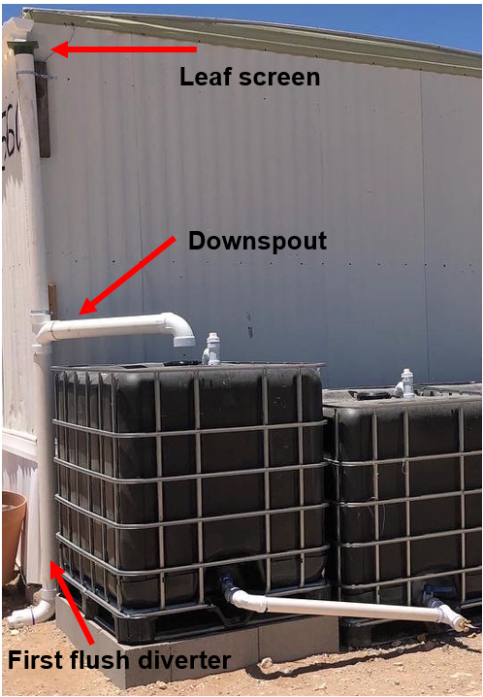

Example System 2

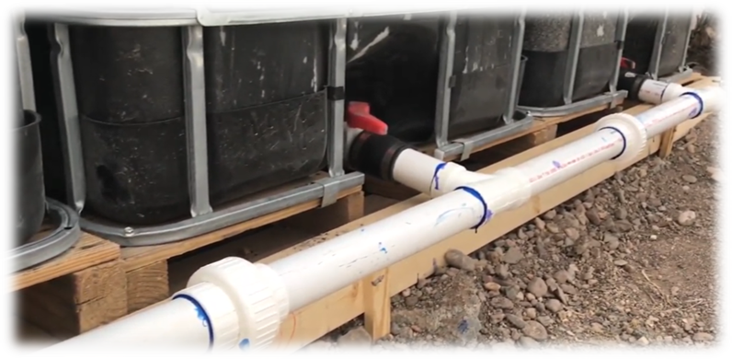
Installing Tanks: Many tanks can be connected in series to increase the capacity of the system. They can be linked from the top or bottom with plastic (PVC) pipes. Make sure that there is enough space to walk around the tanks to check for and repair leaks, and to do inspections (like checking for cracks and chips). The tanks should have tight lids or tops to prevent animals and pests like mosquitoes from getting inside. However, these need to be vented to prevent a vacuum from forming in the tank when large amounts of water are taken out fast. The tanks can be vented by making a hole to the top of the tank and adding a vent cap to it that has mesh on it.
If the system is gravity fed, then a valve or spigot needs to be added to release the water. Use a hose or container to take the water to the required areas. Think about the place where you will be placing the tanks because they can serve many purposes such as shading a garden, providing windbreaks, or as an edge of a structure.

Connected Tanks

Setting Up the Vent

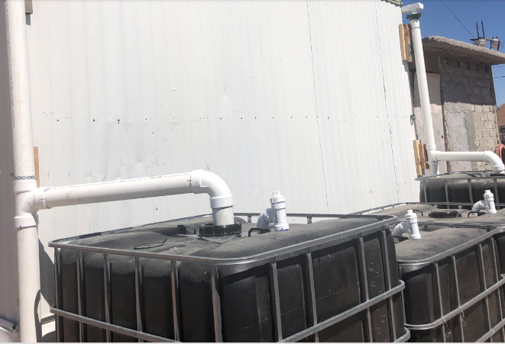
Vents

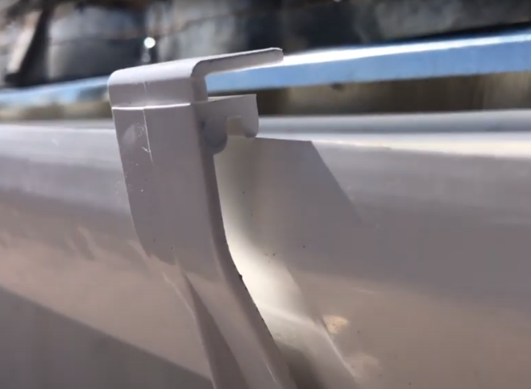
Maintenance: Make sure to trim trees around the roof to have less debris in the gutters and tanks. Long branches may also help animals get into the system. Check all hangers to see if they are connected well and not broken. Also, verify that the slope is still there. Make sure to check the inlet and outlet pipes for anything that might have gotten stuck after big rain events and clean the screens. Check that all lids are closed right, check for damage or leaks, and cracks or settling in the foundation.
Clip Hangers In
Roof and gutter maintenance should be done every six months to prevent trash from getting into the tank.
Chlorinating the water stored in the tank using bleach can prevent algae growth. If the collected water is used to water vegetables, the chlorinated water should not go on the leaves or the produce. You can find information on adding chlorine to your system online. (For example, https://www.cleanwaterstore.com/resource/how-to-guides/how-much-chlorine-to-add-to-storage-tank-to-kill-bacteria/#:~:text=A%20general%20rule%20of%20thumb,every%20250%20gallons%20of%20water ).
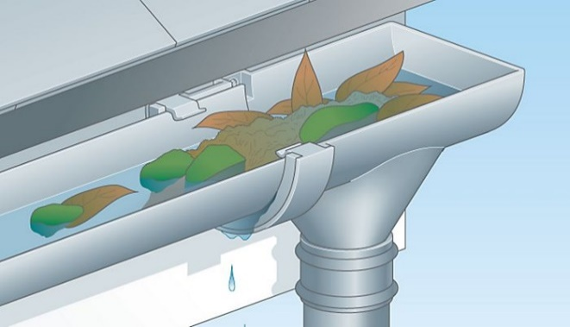
Monitoring: Monitor how much water is in the tank after the rain, using a wooden meter stick or a wooden pole that has been measured and marked to see the water level. The monitoring is so that residents can know how much water they have left. Knowing how much is left will let them see if they need to prioritize using the water or if they need to reduce use in certain areas.
GO AHEAD INSTALL YOU OWN RAINWATER HARVESTING SYSTEM!!!
Adding Chlorine

Clean Gutters

Quick Cost Guide
Material | Unit Price | Amount | Total Per Item
Gutters | $8.38 | 16 | $134.08
Flashing | $2.44 | 16 | $39.04
Downspout | $7.48 | 4 | $29.92
3 in  Cleanout closure | $5.74 | 4 | $22.96
Glue/primer | $8.98 | 1 | $8.98
3 in T | $4.98 | 4 | $19.92
3 in Elbow | $4.48 | 12 | $53.76
3 in Pipe 20 ft | $32.60 | 2 | $65.20
2 in T | $2.12 | 4 | $8.48
2 in Elbow | $1.00 | 4 | $4.00
2 in Pipe 20 ft | $14.99 | 2 | $29.98
Hanger | $3.68 | 32 | $117.76
Connector | $5.28 | 14 | $73.92
End cap | $4.58 | 4 | $18.32
Hose bibb | $6.98 | 4 | $27.92
Green square grate | $4.08 | 4 | $16.32
Cinder blocks | $1.97 | 36 | $70.92
Teflon tape | $1.53 | 1 | $1.53
One-pound box of screws | $3.47 | 1 | $3.47
Roll of metal band | $5.48 | 1 | $5.48
Hose fitting adaptor | $1.18 | 4 | $4.72
2 in female adapter | $1.98 | 8 | $15.84
275-Gallon IBC totes | $ 50.00 | 6 | $300.00

Total Material Cost: $772.52
Total with tanks: $1,072.52
The cost shown here is an example of the total cost of a rainwater harvesting system
On average, material costs range between $500-1000, tanks not included. The cost of tanks ranges between 0-$1000 each, depending on size. It is possible to get free tanks from some businesses willing to donate them. (For example, Coca-Cola and others; always use only tanks that have stored food-grade materials; do not use tanks that have had industrial or harmful chemicals stored in them).

